**KANTO SAFARI ZONE RESEARCH**

Analysis by [Professor Rex](https://www.youtube.com/channel/UCqsQ925jAVYz-asz--B5Nfw)/[Rex_PHD](https://www.instagram.com/rex_phd/)

Forward:

Recently I was working on a video to detail the top 10 rarest shiny Pokémon in generation 3. What I’ve stumbled upon while researching for this video is huge. For years, any knowledgeable shiny hunter would have told you that it is never worth it to throw bait in the Safari zone and that a “balls only” approach is the way to go. Until just this week I would have said the same, until I noticed something on Bulbapedia while doing research… FRLG use a very peculiar formula for determining catch rates, so I decided to dig into it a little. Using new discoveries detailed in this paper, I have found a previously unknown method to increase Chansey's catch rate by a massive 86% over balls alone.

TO SKIP TO THE CATCH GUIDE: CLICK HERE [VIDEO VERSION OF THIS RESEARCH: CLICK HERE](https://youtu.be/y81nojEHKh8)

The Catch Factor

[From Bulbapedia Courtesy of KelvSYC](https://bulbapedia.bulbagarden.net/w/index.php?title=Kanto_Safari_Zone&oldid=1426643):

**NOTE:** The Following information has errors, but it was where I started

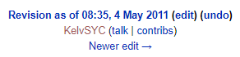*“The Safari Game mechanics were overhauled to more closely resemble the one in the Hoenn Safari Zone. Like it, there is an additional "catch factor" that begins at 100/1275 of the Pokémon's catch rate (rounded down). … If Rocks are thrown, it will be "angry" for 2-6 turns, during which the catch factor is doubled. Being "angry" or "eating" is mutually exclusive, though modifications to the catch factors will stack (reverting to its original value whenever the Pokémon is neither "angry" nor "eating"). Whenever a Safari Ball is thrown, the catch factor is converted back to a catch rate by multiplying by 1275/100 and rounding down.”*

It seems like nobody had considered the ramifications of the rounding that occurred after the division. If you divide a number (X), by another number (Y), floor it, and then multiply it by the same number, (Y again) the result will always be ≤ the original

FLOOR(X/Y) * Y ≤ X

If not for the rounding obviously the values wouldn’t change (X/Y) * Y = X

However, since floating point numbers are not preserved, we end up with major changes to the catch rates of the Pokémon in the safari zone.

The figure below lists the changes that are made to the catch rate of each Pokémon because of this rounding. I have tested these rates using a LUA script in VBA-rerecording and the results indicate that there is in fact a lower catch rate in the Safari Zone which shall be deemed the “Base Safari Zone Catch Rate”  
Kangaskhan Testing:

Odds of capture with catch rate 45 and safari ball: 9.3%

Odds of capture with catch rate 38 and Safari Ball: 8.1%

N = 5000, captures = 353, Catch rate: 7.06% Closer to 8% than 9%

Chansey Testing:

Odds of capture with catch rate 30 and safari ball: 6.2%

Odds of capture with catch rate 25 and Safari Ball: 4.9%

N = 6000, Captures = 257, Catch Rate: 4.2% Closer to 5% than 6%

Obviously not definitive but enough for our purposes here.

NOTE: All code snippets were added in May of 2020, the original document was written in August of 2019

Reviewed by Phifir

pp_rand() update December 2020

Brock Strat update August 2023

VER 6.0b (2023-09-07)

|  |  |  |  |
| --- | --- | --- | --- |
| **FR/LG Base Catch Rates** | | | |
| Pokémon | Base Catch Rate | Catch Factor | Base Safari Catch Rate (Per Ball) |
| [Chansey](https://bulbapedia.bulbagarden.net/wiki/Chansey_(Pok%C3%A9mon)) | 30 | 2 | 25 (4.9%) |
| [Kangaskhan](https://bulbapedia.bulbagarden.net/wiki/Kangaskhan_(Pok%C3%A9mon))[Scyther](https://bulbapedia.bulbagarden.net/wiki/Scyther_(Pok%C3%A9mon))[Pinsir](https://bulbapedia.bulbagarden.net/wiki/Pinsir_(Pok%C3%A9mon))[Tauros](https://bulbapedia.bulbagarden.net/wiki/Tauros_(Pok%C3%A9mon))[Dragonair](https://bulbapedia.bulbagarden.net/wiki/Dragonair_(Pok%C3%A9mon))[Dratini](https://bulbapedia.bulbagarden.net/wiki/Dratini_(Pok%C3%A9mon)) | 45 | 3 | 38 (8.1%) |
| [Seaking](https://bulbapedia.bulbagarden.net/wiki/Seaking_(Pok%C3%A9mon)) | 60 | 4 | 51 (10.7%) |
| [Parasect](https://bulbapedia.bulbagarden.net/wiki/Parasect_(Pok%C3%A9mon))[Venomoth](https://bulbapedia.bulbagarden.net/wiki/Venomoth_(Pok%C3%A9mon)) | 75 | 5 | 63 (12.3%) |
| [Exeggcute](https://bulbapedia.bulbagarden.net/wiki/Exeggcute_(Pok%C3%A9mon)) | 90 | 7 | 89 (19.8%) |
| [Nidorino](https://bulbapedia.bulbagarden.net/wiki/Nidorino_(Pok%C3%A9mon))[Nidorina](https://bulbapedia.bulbagarden.net/wiki/Nidorina_(Pok%C3%A9mon))[Rhyhorn](https://bulbapedia.bulbagarden.net/wiki/Rhyhorn_(Pok%C3%A9mon)) | 120 | 9 | 114 (23.4%) |
| [Paras](https://bulbapedia.bulbagarden.net/wiki/Paras_(Pok%C3%A9mon))[Venonat](https://bulbapedia.bulbagarden.net/wiki/Venonat_(Pok%C3%A9mon))[Psyduck](https://bulbapedia.bulbagarden.net/wiki/Psyduck_(Pok%C3%A9mon))[Slowpoke](https://bulbapedia.bulbagarden.net/wiki/Slowpoke_(Pok%C3%A9mon))[Doduo](https://bulbapedia.bulbagarden.net/wiki/Doduo_(Pok%C3%A9mon)) | 190 | 14 | 178 (40.1%) |
| [Goldeen](https://bulbapedia.bulbagarden.net/wiki/Goldeen_(Pok%C3%A9mon)) | 225 | 17 | 216 (50.3%) |
| [Nidoran♀](https://bulbapedia.bulbagarden.net/wiki/Nidoran%E2%99%80_(Pok%C3%A9mon))[Nidoran♂](https://bulbapedia.bulbagarden.net/wiki/Nidoran%E2%99%82_(Pok%C3%A9mon)) | 235 | 18 | 229 (50.3%) |
| [Magikarp](https://bulbapedia.bulbagarden.net/wiki/Magikarp_(Pok%C3%A9mon))[Poliwag](https://bulbapedia.bulbagarden.net/wiki/Poliwag_(Pok%C3%A9mon)) | 255 | 20 | 255 (50.3%) |

Note: This chart can be found on Bulbapedia but was made by the producer of this document ([Shiny TRex](https://bulbapedia.bulbagarden.net/wiki/Special:Contributions/Shiny_TRex) on the wiki)

To dig a little deeper, I found the RAM addresses of the “Catch Factor” and played around with them a little. Some things that were discovered worth mentioning are:

Snippet of code* that demonstrates the minimum catch rate of 3 after bait

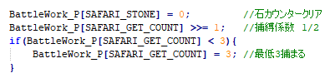

-The catch factor remains modified, even after a Pokémon is no longer angry or eating.

-The catch factor can be influenced by multiple baits, or rocks

-The catch factor cannot be reduced below 3, or increased above 20

Snippet of code* that demonstrates how a catch factor is converted back into a catch rate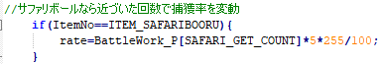

- Once the catch factor is modified it is never reset

Snippet of code* that shows the catch bonus of 1.5x on the Safari Ball (SAFARIBOORU)

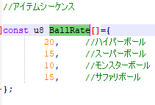

Snippet of code* that demonstrates how a catch rate is converted into a catch factor



*Code snippets are pulled directly from the FRLG Source Code

Example: Magikarp has a base catch factor of 20,

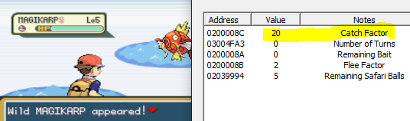

As we can see in the first turn the amount of remaining bait is 0

after being baited once it becomes 10,

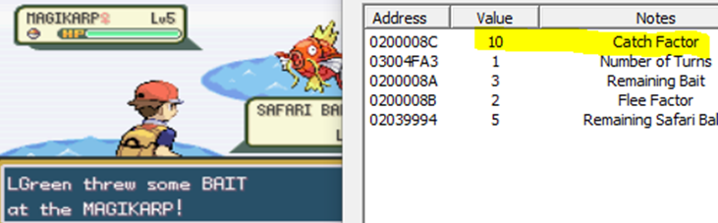

After the first throw it increases to 3, which means we got a roll of 3 on our bait roll

after a second time it becomes 5,

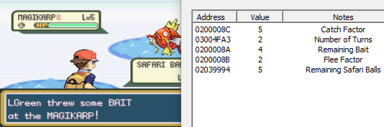

and very importantly a third bait will reduce it to 3,

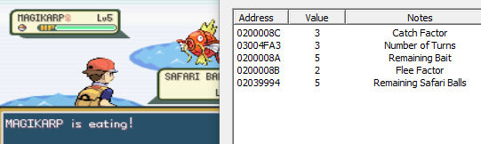

a fourth bait will not reduce the catch factor below 3.

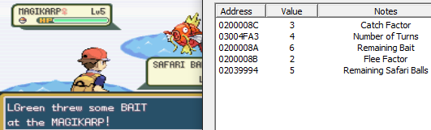

Note that the amount of bait only increased from 5-6. This demonstrates the maximum of 6

A rock will increase the catch factor to 6 from 3.

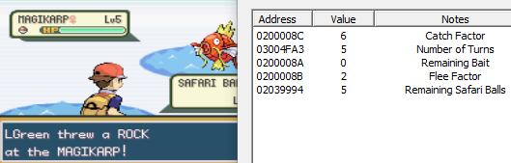

The fact that there seemed to be a minimum catch rate was exciting. This was the first time I had come across any proof to back up claims made by [kelvSYC in a Serebii post from 2010](https://forums.serebii.net/threads/safari-zone-by-the-numbers.445338/).

*“To determine whether a Safari Zone Pokémon is caught, you use the following formula: S = C * (100 / 1275) * (M + 1 / B + 1), where C is the Pokémon's catch rate, M is the number of times you threw mud, and B is the number of times you threw bait. If S is smaller than 3, set it to 3, and if it is bigger than 20, set it to 20.”*

Although Kelv wasn’t completely correct, the minimum “Catch Factor” was about to have some major repercussions for Chansey and the gang. Chansey’s base catch factor is 2. The values from my RAM watch indicated that this was true. However, this minimum catch factor of 3 only applies after a bait has been thrown. Check this out…



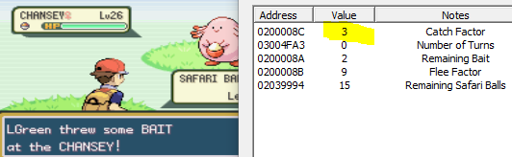

This means a single bait can increase the catch rate per ball of Chansey from 4.9% to 8.1% for the rest of the encounter!

Additionally, all the Pokémon who already have a catch factor of 3 don’t have it reduced by bait



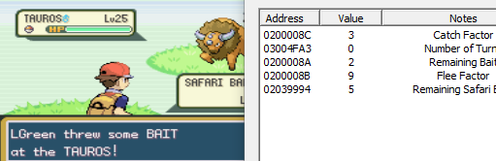

Flee Factor  
Unlike the catch factor, which is modified each time bait or balls are thrown, the flee factor is determined once and has calculations preformed upon it without changing. The flee factor is determined by taking a Pokémon’s base flee rate and multiplying it by 100/1275 then rounding down. Each Pokemon from the safari zone has a set flee rate, which was pulled from a [disassembly of Pokemon Firered](https://github.com/pret/pokefirered/blob/master/README.md).

|  |  |  |  |
| --- | --- | --- | --- |
| **FR/LG Flee Rates** | | | |
| Pokémon | Base Flee Rate | Baited Flee Factor | Angered Flee Factor |
| [Magikarp](https://bulbapedia.bulbagarden.net/wiki/Magikarp_(Pok%C3%A9mon)) | 25 (10%) | 1 (5%) | 2 (10%) |
| [Nidoran♀](https://bulbapedia.bulbagarden.net/wiki/Nidoran%E2%99%80_(Pok%C3%A9mon))[Nidoran♂](https://bulbapedia.bulbagarden.net/wiki/Nidoran%E2%99%82_(Pok%C3%A9mon))[Paras](https://bulbapedia.bulbagarden.net/wiki/Paras_(Pok%C3%A9mon))[Venonat](https://bulbapedia.bulbagarden.net/wiki/Venonat_(Pok%C3%A9mon))[Psyduck](https://bulbapedia.bulbagarden.net/wiki/Psyduck_(Pok%C3%A9mon))[Poliwag](https://bulbapedia.bulbagarden.net/wiki/Poliwag_(Pok%C3%A9mon))[Slowpoke](https://bulbapedia.bulbagarden.net/wiki/Slowpoke_(Pok%C3%A9mon))[Doduo](https://bulbapedia.bulbagarden.net/wiki/Doduo_(Pok%C3%A9mon))[Goldeen](https://bulbapedia.bulbagarden.net/wiki/Goldeen_(Pok%C3%A9mon)) | 50 (15%) | 1 (5%) | 6 (30%) |
| [Nidorino](https://bulbapedia.bulbagarden.net/wiki/Nidorino_(Pok%C3%A9mon))[Nidorina](https://bulbapedia.bulbagarden.net/wiki/Nidorina_(Pok%C3%A9mon))[Parasect](https://bulbapedia.bulbagarden.net/wiki/Parasect_(Pok%C3%A9mon))[Venomoth](https://bulbapedia.bulbagarden.net/wiki/Venomoth_(Pok%C3%A9mon))[Exeggcute](https://bulbapedia.bulbagarden.net/wiki/Exeggcute_(Pok%C3%A9mon))[Rhyhorn](https://bulbapedia.bulbagarden.net/wiki/Rhyhorn_(Pok%C3%A9mon))[Seaking](https://bulbapedia.bulbagarden.net/wiki/Seaking_(Pok%C3%A9mon)) | 75 (25%) | 1 (5%) | 10 (50%) |
| [Dratini](https://bulbapedia.bulbagarden.net/wiki/Dratini_(Pok%C3%A9mon)) | 100 (35%) | 1 (5%) | 14 (70%) |
| [Chansey](https://bulbapedia.bulbagarden.net/wiki/Chansey_(Pok%C3%A9mon))[Kangaskhan](https://bulbapedia.bulbagarden.net/wiki/Kangaskhan_(Pok%C3%A9mon))[Scyther](https://bulbapedia.bulbagarden.net/wiki/Scyther_(Pok%C3%A9mon))[Pinsir](https://bulbapedia.bulbagarden.net/wiki/Pinsir_(Pok%C3%A9mon))[Tauros](https://bulbapedia.bulbagarden.net/wiki/Tauros_(Pok%C3%A9mon))[Dragonair](https://bulbapedia.bulbagarden.net/wiki/Dragonair_(Pok%C3%A9mon)) | 125 (45%) | 2 (10%) | 18 (90%) |

Note: This chart can be found on Bulbapedia but was made by the producer of this document ([Shiny TRex](https://bulbapedia.bulbagarden.net/wiki/Special:Contributions/Shiny_TRex) on the wiki)

The flee factor of a Pokémon cannot be less than 2 when encountered. Despite Magikarp’s base flee factor being calculated as 1, it will be increased up to 2 upon encountering it.

After bait the minimum flee factor is 1, which is equal to 5%

Pseudo code for determining flee factor:

Snippet of code* that displays the floor of 2 (10%) to flee rates when a Pokémon is first encountered 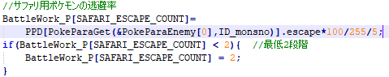

if (eating):

M = ¼

elif (angry):

M = 2

else:

M = 1

Snippet of code* that displays the floor of 1 (5%) to flee rates after bait

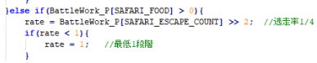

base flee factor = floor((Flee Rate) x 1275/100)

modified flee factor = floor((base flee factor) x M)

flee factor to use = max(modified flee factor, 2)

Bait

At the start of a turn the game will check to see if there is any bait left in front of a Pokémon. If there is, it will eat. A turn that starts with a Pokémon who is eating will have a 10% flee chance on all Pokémon with a 125 base flee rate, or a 5% chance to flee for all others. The first turn, or any turn that starts with the Pokémon watching carefully, will use the regular flee chance during the flee check.

When bait is thrown, a ‘pile’ of bait will be put in front of the Pokémon. Each time a bait is thrown this pile will increase by 2-6 ‘bites’ of bait, to a maximum of six bites of bait. For example: if a Pokémon who is already eating and still has 3 ‘bites’ of bait in front of it gets given more bait the pile will increase by 2, or 3 as it cannot surpass 6. From what I can tell, the odds of giving any amount of bait seems to be evenly distributed, so there is a 1/5 chance to give 2 ‘bites’ of bait, just as there is a 1/5 chance to give 4.

Snippet of code* that demonstrates how adding bait works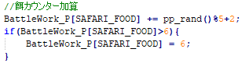

At the start of a turn the game will preform a flee check. This begins by having the amount of bait reduced by one, and then seeing if there is any bait remaining. If there is at least one bait left the flee check will be done with reduced rates. Since the flee check is done at the start of the turn, bait does not take effect on a “watching carefully” Pokémon until the next turn. On the first turn, even if bait is thrown the flee check will use full flee factor odds.

Once the ball or bait have been thrown the game will check for the results of the flee check that was preformed at the start of the turn. The flee check is done by generating a random number from 0-99 inclusive, and comparing it to 5x the flee factor. If the random number is less, the flee check is successful. A successful flee check will cause the Pokémon to flee; otherwise the next turn will take place. Pokémon with a base flee rate of 125 have a flee factor of 9; this results in a 45% chance to flee. An eating Pokémon will have a flee rate of 10% per turn if it’s base flee rate is 125, or 5% otherwise.  
  
At the very start of each turn the amount of bait will be reduced by one. This decrease will take place even if bait was just thrown so the maximum number of ‘bites’/turns of bait that can be stacked is equal to the max pile size – 1 = (6) – 1 = 5 Turns. Since the minimum roll of a bait throw is 2 the lowest number of “eating” turns that can be granted from a bait roll is one.

It should be noted that contrary to Bulbapedia and other sources this means that the number of turns of anger or eating granted from rocks/bait is 1-5 instead of 2-6

Snippet of code* that demonstrates how eating checks work

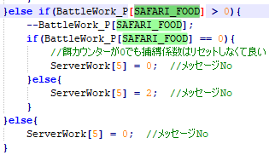

This code runs at the start of the turn, will see if there is any bait remaining, and reduce the total by one. It then sees if there is any bait left and preforms a flee check. This flee check’s success is stored to be used at the end of the turn.

Snippet of code* that demonstrates how the flee checks work

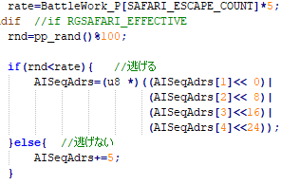

This code multiplies the

flee factor by 5 and

compares it to a

random value between

0 & 99, less causes a flee

Example: Two ‘bites’ of bait are added to the pile on the first throw, 1 eating turn is granted.

*To see bait stacking effects, refer to the Magikarp example*

Tauros is encountered and has no bait in front of it, for this turn it is considered to be ‘watching carefully’



A bait is thrown and 2 bait is added to the pile. Flee check will be preformed with a 45% flee rate

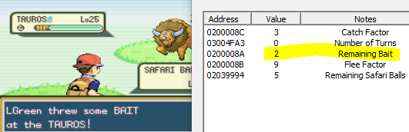

Amount of bait is reduced by one. The game will preform the eating check. Since there is bait the Pokémon will be eating for this turn’s flee check.

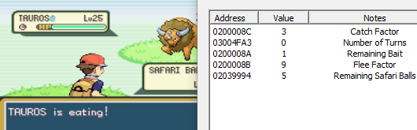

After a bait or a ball is thrown the Flee check will occur. Since the Pokémon is eating the odds of it fleeing will be 10%

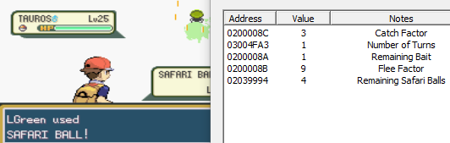

If the Flee check is unsuccessful the Pokémon will not flee, bait is reduced by one and the ‘Eating check’ is preformed. Since there is no bait remaining, it will be watching carefully this turn.

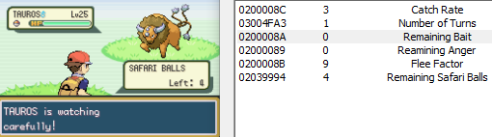

**THE NUMBERS! (EXCITING STUFF)**I’ve created a program, which works with all the new information that I have discovered to calculate the probabilities of catching Pokémon in the Safari Zone. [Source Code can be found here!](https://github.com/ProfessorRex/Safari-Zone-Research/blob/master/FRLG_SAFARI_ZONE_CALCULATOR%20-%20V4a.py)

Prior to what was previously accepted, I have determined the odds of successfully catching Chansey goes from

10.28% to 19.08% by utilizing a pattern of both bait and balls.

Full output of the program can be found at the end of this document.

Utilizing bait effectively can save you hundreds of thousands of encounters in your hunt for any of the rarer spawns.

|  |  |  |  |  |  |  |  |  |  |
| --- | --- | --- | --- | --- | --- | --- | --- | --- | --- |
|  | Pokémon | Encounter Method | Base Encounter Rate | Best Repel Trick Encounter Rate | Odds of Capture (Balls Only) | Odds of capture (Optimal) | Average # of encounters to FIND a shiny (Best Rate) | Average # of encounters to CATCH a shiny (Balls Only) | Average # of encounters to CATCH a shiny (Optimal) |
|  | Dragonair (Level 25) |  | 0.091% |  | 16.35% | 19.08% | 9,015,878 | 55,137,504 | 47,258,142 |
|  | Dragonair (Underleveled) |  | 0.454% |  | 16.35% | 19.08% | 1,803,176 | 11,027,501 | 9,451,628 |
|  | Dragonair |  | 1% |  | 16.35% | 19.08% | 819,650 | 5,012,653 | 4,296,326 |
|  | Chansey  (Level 23) |  | 1% | 1.54% | 10.28% | 19.08% | 532,730 | 5,184,695 | 2,792,389 |
|  | Chansey |  | 4% | 5.33% | 10.28% | 19.08% | 153,713 | 1,495,978 | 805,709 |
|  | Tauros |  | 4% | 6.15% | 16.35% | 19.08% | 133,183 | 814,491 | 698,097 |
|  | Kangaskhan |  | 4% | 8% | 16.35% | 19.08% | 102,450 | 626,543 | 537,008 |
|  | Scyther (FR) |  | 4% | 9.09% | 16.35% | 19.08% | 90,112 | 551,089 | 472,336 |
|  | Pinsir (LG) |  | 4% | 9.09% | 16.35% | 19.08% | 90,112 | 551,089 | 472,336 |
|  | Dratini |  | 14.99% |  | 20.08% | 33.13% | 54,643 | 272,125 | 164,767 |
|  | Parasect |  | 5% | 25% | 35.98% | 38.62% | 32,768 | 91,071 | 84,734 |
|  | Paras |  | 15% |  | 82.21% |  | 54,643 | 66,471 |  |
|  | Venonat |  | 15% | 18.75% | 82.21% |  | 43,691 | 53,147 |  |
|  | Seaking (Underleveled) |  | 40.03% |  | 32.29% | 38.62% | 20,463 | 63,376 | 52,915 |
|  | Exeggcute |  | 20% | 33.33% | 49.59% |  | 24,578 | 49,567 |  |
|  | Poliwag |  | 19.99% |  | 87.07% |  | 40,983 | 47,066 |  |
|  | Rhyhorn |  | 20% | 40% | 54.99% |  | 20,480 | 37,241 |  |
|  | Venomoth |  | 5% | 100% | 35.98% | 38.62% | 8,192 | 22,768 | 21,183 |
|  | Nidoran♀ (LG) |  | 20% | 50% | 87.07% |  | 16,384 | 18,816 |  |
|  | Nidoran♂ (FR) |  | 20% | 50% | 87.07% |  | 16,384 | 18,816 |  |
|  | Goldeen |  | 60.02% |  | 87.07% |  | 13,648 | 15,674 |  |
|  | Doduo |  | 20% | 64.52% | 82.21% |  | 12,697 | 15,445 |  |
|  | Nidorina (LG) |  | 10% | 100% | 54.99% |  | 8,192 | 14,897 |  |
|  | Nidorino (FR) |  | 10% | 100% | 54.99% |  | 8,192 | 14,897 |  |
|  | Slowpoke (LG) |  | 100% |  | 82.21% |  | 8,192 | 9,965 |  |
|  | Psyduck (LG) |  | 100% |  | 82.21% |  | 8,192 | 9,965 |  |
|  | Magikarp |  | 100% |  | 90.99% |  | 8,192 | 9,003 |  |

[The Above Chart can be found here](https://docs.google.com/spreadsheets/d/1U24r3E-79kB41iJU35NNIuqvQ2iB_cd64hHcdVN8F58/edit?usp=sharing)

**OPTIMAL PATTERNS:**

To determine the optimal patterns for each bait-benefiting Pokémon I created a function that ran through many, many simulations of bait patterns. This allowed me to determine algorithms that give players the absolute highest probability to catch Pokémon with any number of remaining balls. These patterns are not just guessed either. They have been determined by comparing them against thousands, and in some cases hundreds of thousands, of other possibilities.

**Chansey:**Chansey sees a huge 85.65% improvement to its success rate with an optimal pattern. (10.28% vs 19.08%)

Snagging a catch rate-improvement and a flee-rate reduction is a huge buff to get from a single bait. Don’t miss your chance(y) and stuff your target full of bait!

If you encounter a Chansey that you wish to capture take a note of your current balls and use the corresponding pattern from **Look-up Table 1**. After a bait has been thrown Chancey’s catch factor will be increased to 3. If it begins to ‘watch carefully’ take note of your remaining number of balls and refer to **Look-up Table 2**. Discard the pattern you had been using previously and start over with the new pattern.

It is interesting to note that Chansey benefits so greatly from bait that even if you encounter one with only two balls left you are more likely to capture it if you open with a bait instead of just throwing both balls. (7.47% vs 8.13%)

**Dragonair, Tauros, Scyther, Pinsir, & Kangaskhan:**

These Pokémon do not benefit as greatly from bait as Chansey; however, their success rate does improve by 16.66% with an optimal pattern. (16.35% vs 19.08%) It might not be much but when rolling the dice with a shiny Pokémon every little bit helps!

Since each of these Pokémon have a standard catch-factor of 3, bait will not make them any less likely to be captured; however, it will reduce their probability to flee from 45% to just 10% until they stop eating.

When you encounter one of these Pokémon take note of your current balls and use the corresponding pattern from **Look-up Table 2**. If it begins to ‘watch carefully’ take note of your remaining balls and refer to **Look-up Table 2**once again. Discard the pattern you were using and start over with the new pattern.

The odds still aren’t great but with a little luck hopefully they will stay in the ball.

**Dratini:**

Dratini is the only Pokémon in the FR/LG Safari Zone with a base flee rate of 100. With a slightly lower chance to flee (35% vs 45%) than other rare Pokémon, the patterns end up being quite different. Since it’s flee rate while eating is just 5% per turn Dratini has the best odds of capture with a more conservative bait pattern; often utilizing a bait followed by just two balls. Dratini sees a massive improvement of 64.99% to its success rate with an optimal pattern.

(20.08% vs 33.16%)  
  
To capture Dratini take note of your remaining balls and use the corresponding pattern from **Look-up Table 3**. If it begins to ‘watch carefully’ take note of your remaining balls and refer to **Look-up Table 3**once again. Discard the pattern you were using and start over with the new pattern.

**Seaking:**

Seaking is an interesting case, with the prior assumption that flee rates were always floored at 10% it wasn’t initially thought to benefit from bait. However, the source code leak revealed that there is a 5% floor after bait. With this Seaking gains a 19.76% improvement to its success rate with bait (32.29% vs 38.67%) even after taking a slight hit to it’s catch rate (10.66% -> 8.09%).

To capture Seaking take a note of your current balls and use the corresponding pattern from **Look-up Table 4**. After a bait has been thrown Seaking’s catch factor will be reduced to 3. If it begins to ‘watch carefully’ take note of your remaining number of balls and refer to **Look-up Table 6**. Discard the pattern you had been using previously and start over with the new pattern.

**Parasect & Venomoth:**

Parasect and Venomoth are very similar to Seaking, they just take a slightly bigger hit to their per-ball catch rate after using bait (12.33% -> 8.09%). However, they still see a 7.48% improvement to their success rate with bait (35.98% vs 38.67%).

To capture Parasect or Venomoth take a note of your current balls and use the corresponding pattern from **Look-up Table 5**. After a bait has been thrown their catch factor will be reduced to 3. If the Pokémon begins to ‘watch carefully’ take note of your remaining number of balls and refer to **Look-up Table 6**. Discard the pattern you had been using previously and start over with the new pattern.

**Look-up Tables:**

There are three look up tables listed below. They are to be used in conjunction with the instructions found above.  
To uses these charts effectively just take your number of balls and use the corresponding pattern until you: catch the Pokémon, it flees, or it begins to ‘watch carefully’ (runs out of bait). If the Pokémon begins to watch carefully take your number of remaining balls and start fresh with the given pattern from the correct table.  
  
**Look-up Table 1** is only to be used on Chansey that have not yet have bait thrown at them. After throwing bait once its catch rate will be increased for the rest of the encounter. At which point it is effectively the same as most other rare Safari Zone Pokémon. If Chansey begins to watch carefully and at least one bait has been thrown at it refer to Look-up Table 2.  
  
**Look-up Table 2** is created for all Pokémon who have a catch factor of 3 and a flee rate of 125. This includes Dragonair, Tauros, Scyther, Kangaskhan, Pinsir. It also includes Chansey who have eaten bait. Use this table as described in “Optimal Patterns” above.

**Look-up Table 3** is created for catch factor 3, flee rate 100 Pokémon. This only includes Dratini. Use this table as described in “Optimal Patterns” above.  
  
**Look-up Table 4** is only to be used on Seaking that have not yet have bait thrown at them. After throwing bait its catch rate will be decreased for the rest of the encounter. At which point it is effectively the same as a Pokémon with a catch factor of 3, and a flee rate of 75. If Seaking begins to watch carefully and at least one bait has been thrown at it refer to Look-up Table 6. Use this table as described in “Optimal Patterns” above.  
  
**Look-up Table 5** is only to be used on Parasect or Venomoth that have not yet been baited. After throwing bait their catch rate will be decreased for the rest of the encounter. At which point it is effectively the same as a Pokémon with a catch factor of 3, and a flee rate of 75. If the Pokémon begins to watch carefully and at least one bait has been thrown at it refer to Look-up Table 6. Use this table as described in “Optimal Patterns” above.

[**High Resolution Look-up Charts can be found here**](https://www.docdroid.net/g3I5Qtl/frlg-lookup-tables-pdf)

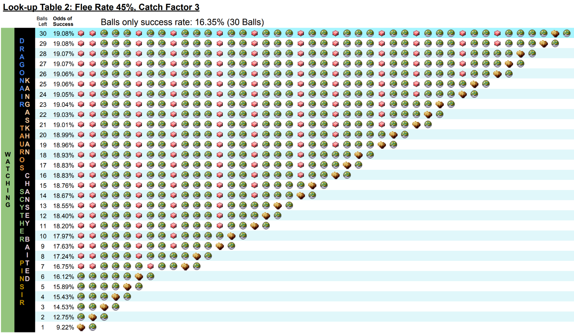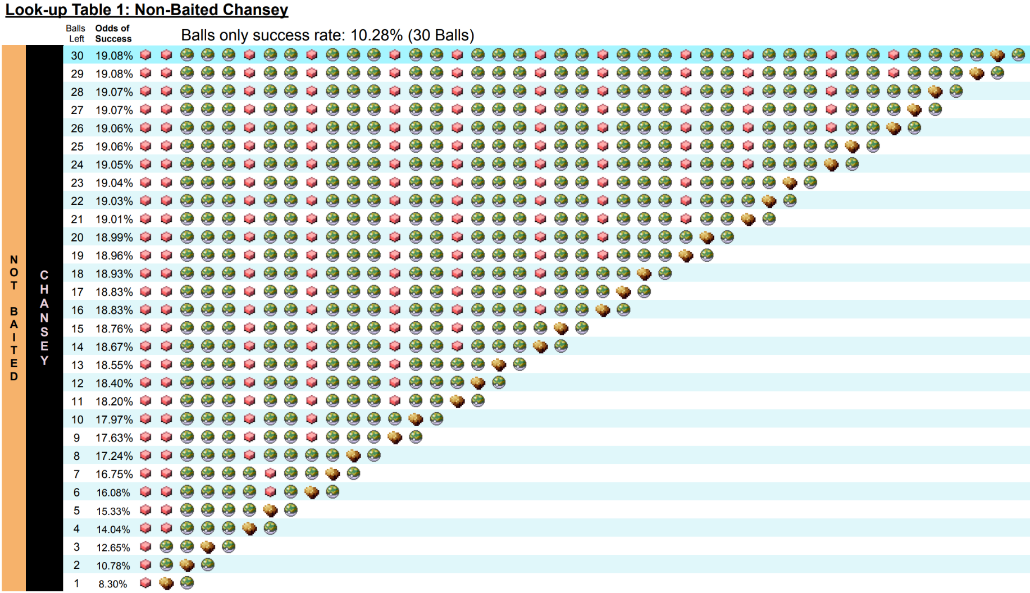

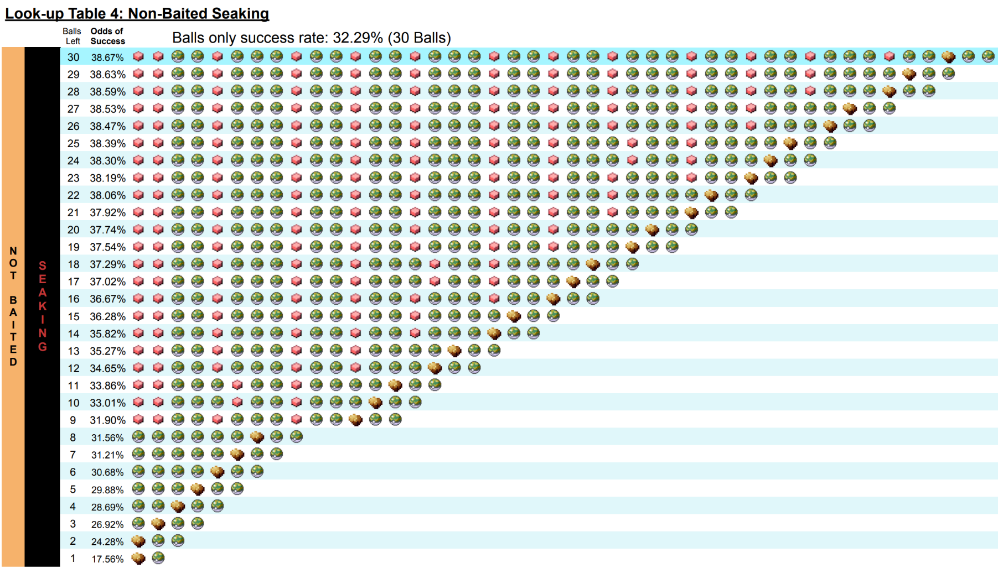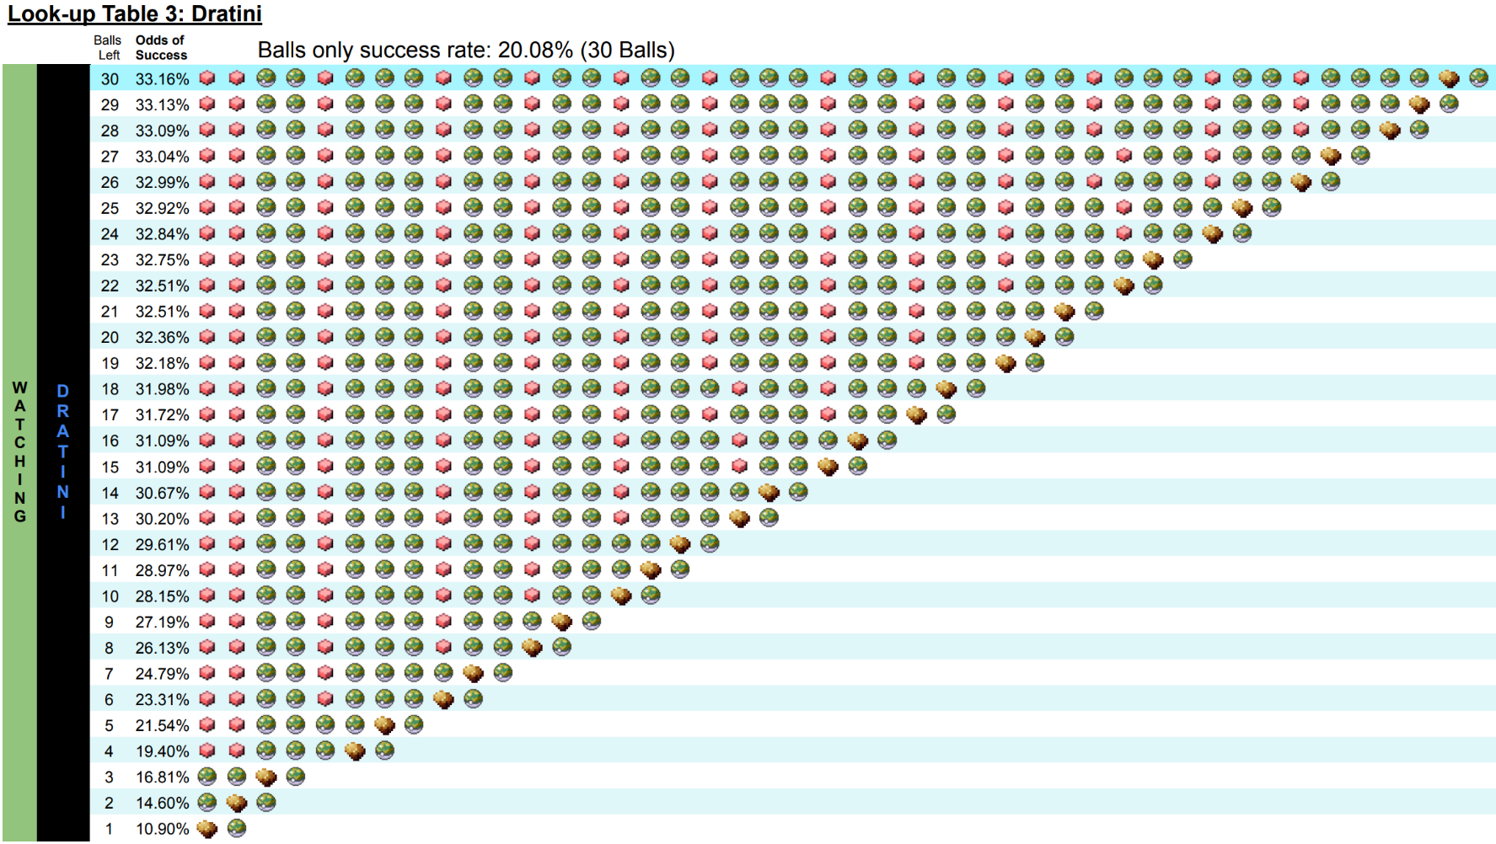

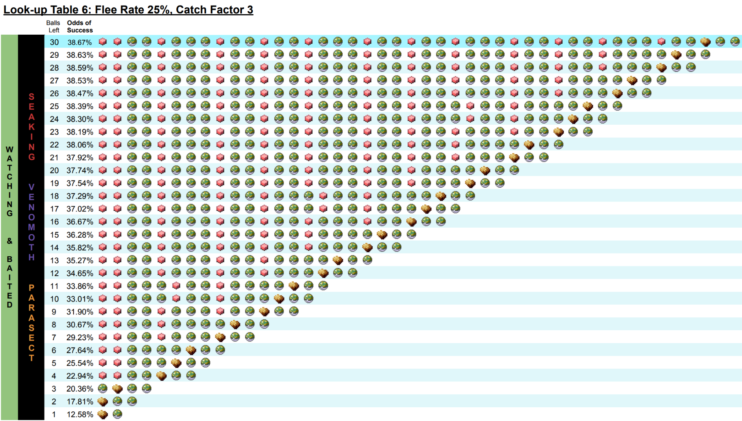 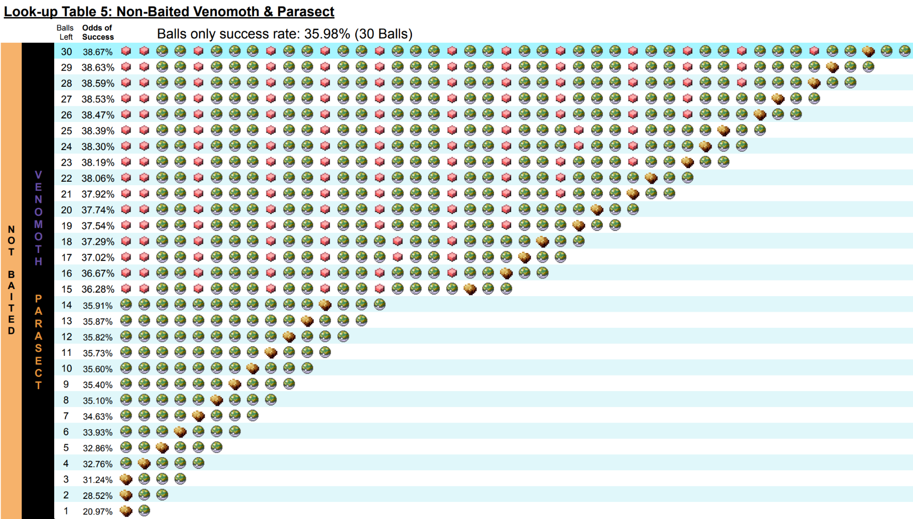

If anyone can find better patterns, I would be extremely interested to hear your ideas.

All of my [source code can be found here](https://github.com/ProfessorRex/Safari-Zone-Research/blob/master/FRLG_SAFARI_ZONE_CALCULATOR%20-%20V4a.py) and I can be emailed directly at:

[the.professor.rex@gmail.com](mailto:the.professor.rex@gmail.com)

**What’s the Deal with pp_rand()?**

*A footnote on random number generation in the Safari Zone*

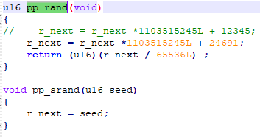In Pokémon Firered/Leafgreen the starting seed is determined when you go from the start screen into the game. This seed will be in the form of an unsigned 16-bit integer.

It is then transferred to a variable called r_next

This is an unsigned long integer (32 bits)

this can store a number between 0 -> 4,294,967,295  
This results in (2^32) possible states for the r_next variable.

For PRNG (pseudo-random number generation) advancements an arbitrary function is applied to r_next.

To generate a 16-bit seed for random calls:

r_next is divided by 65,536 (which is equal to 2^16)

When the random number call is preformed there is an issue though...

The seed has an even distribution among all results of 0-65535

however, the safari zone flee checks use a modulo 100 expression to roll a random number between 0-99

65,6536 is not evenly divisible by 100 so there is an uneven distribution for probability of rolls.

seed % 100 has a:

656/65536 probability to generate a number between 0 -> 35 (per number)

and a

655/65536 probability to generate a number between 36 -> 99 (per number)

This means with Chansey's flee check of 45 is slightly more likely to succeed (causing a flee) than 45%

The real probability to flee is equal to:

(36 * 656/65536) + (9 * 655/65536)

= 29511/65536

≃ 45.0302%  
  
A similar (though much less impactful) issue arises with the game’s bait throwing mechanics.  
Since 65,536 is not evenly divisible by 5 there is one more way to roll a bait throw of 2 than each of the other possibilities

Odds to add 2 bait: 13108/65536  
≃ 20.00122%

Odds to add any other number of bait: 13107/65536 (per number)

≃ 19.99969%

Overall, this doesn’t affect the overall probability of catching a Chansey much;  
about 0.02289% per Chansey, but it is interesting!

Most older games probably run into this issue with any “random” chance call that does not have a probability of  
**(x/y²)** | x, y ∈ ℤ+

This oddity also affects encounter rates in a very minor way, Dratini is only actually a 14.992% encounter rate because of pp_rand()’s uneven distribution!

**The Brock Strat (Using Bait & Rocks in the Safari Zone)**

In Pokémon Firered/Leafgreen a Pokémon’s flee check is preformed at the start of the turn. This means that the item used has no impact on if a Pokémon will flee or not on that turn. This means that it is impossible to avoid the 45.03% flee chance for Pokémon like Chansey even when bait is thrown on the first turn. However, it also means that players are able to more easily get a turn in after throwing a rock. Usually this would be completely useless since the Pokémon would have a 90.0055% chance to flee after a single ball was thrown on the next turn. However, it is worth considering what should be done if a player only has a few balls left. With a limited number of balls remaining if the Pokémon is already eating it can be worthwhile to risk one extra turn of possible flee chance at 10.01% in order to boost the catch factor from 3 to 6. With a catch factor of three the odds of catching a Pokémon with a Safari Ball is 8.09%; with a catch factor of 6 that becomes 16.78%. The trade off for running one extra flee check can drastically alter the odds of success when very few balls remain. If a rock is thrown just before the last ball is used the 90.0055% chance to flee is never even rolled since running out of balls ends the player’s Safari Game.  
Upon coming to this realization through the help of [@ShinyCollector](https://www.youtube.com/c/@shinycollector), I wanted to demonstrate that this strategy could actually be viable. To do so I created a [spreadsheet](https://docs.google.com/spreadsheets/d/1PrX5gD6R0Zq8f8SGsbhYI5KSj7xfcWVBfF0WJjwotS4/edit?usp=sharing) that steps through turns and gives us the odds of success; for simplicity I assumed the Pokémon wouldn’t being to ‘watch carefully’ during these simulations.

Under thrown balls is the probability of reaching the state to throw said ball multiplied by the odds of the ball successfully capturing the Pokémon. Under Flee Checks is the probability of reaching the state of a Pokémon remaining at the end of that turn.

|  |  |  |  |
| --- | --- | --- | --- |
| P_Catch @ Catch Factor 3 | P_Catch @ Catch Factor 6 | Flee Rate (Angry) | Flee Rate (Eating) |
| 0.08090370382 | 0.1677555206 | 0.9000549316 | 0.1000976563 |

|  |  |  |  |  |  |
| --- | --- | --- | --- | --- | --- |
| **Pattern: 3 Balls** | Throw a Ball | Flee Check | Throw a Ball | Flee Check | Throw a Ball |
| Probability of Turn | P_Catch @ CF 3 | P_Stay (Eating) | P_Catch @ CF 3 | P_Stay (Eating) | P Catch @ CF 3 |
| 1 | 0.08090370382 | 0.8270969111 | 0.06691520352 | 0.6840893003 | 0.05534535814 |

**Total Probability of Capture:** 0.08090370382 + 0.06691520352 + 0.05534535814 **= 0.2031642655**

|  |  |  |  |  |  |  |
| --- | --- | --- | --- | --- | --- | --- |
| **Pattern: Ball, Rock, Ball, Ball** | Throw a Ball | Flee Check | Throw a ROCK, Flee Check (Eating) | Throw a Ball | Flee Check | Throw a Ball |
| Probability of Turn | P_Catch  @ CF 3 | P_Stay (Eating) | P_Stay  (Eating) | P_Catch  @ CF 6 | P_Stay (Angry) | P_Catch  @ CF 6 |
| 1 | 0.08090370382 | 0.8270969111 | 0.7443064488 | 0.1248615158 | 0.06191046617 | 0.01038582248 |

**Total Probability of Capture:** 0.08090370382 + 0.1248615158 + 0.01038582248 = **0.2161510421**

|  |  |  |  |  |  |  |
| --- | --- | --- | --- | --- | --- | --- |
| **Pattern: Ball, Ball, Rock, Ball** | Throw a Ball | Flee Check | Throw a Ball | Flee Check | Throw a ROCK, Flee Check (Eating) | Throw a Ball |
| Probability of Turn | P_Catch  @ CF 3 | P_Stay (Eating) | P_Catch  @ CF 3 | P_Stay (Eating) | P_Stay (Eating) | P_Catch  @ CF 6 |
| 1 | 0.08090370382 | 0.8270969111 | 0.06691520352 | 0.6840893003 | 0.6156135647 | 0.103272574 |

**Total Probability of Capture:** 0.08090370382 + 0.06691520352 + 0.103272574 = **0.2510914814**

With these numbers it was obvious that it would be worth looking into the use of rocks further.  
For **Chansey, Dragonair, Pinsir, Scyther, Tauros, and Kangaskha**n the final 3 ball success rate goes from **20.32%** to **25.11%** if a rock is used before the **final ball** is thrown.  
For **Dratini** the final 3 ball success rate goes from **21.32%** to **27.30%** if a rock is used before the **final ball** is thrown.  
For **Parasect, Venomoth, and Seaking** the final 3 ball success rate goes from **21.32%** to **27.79%** if a rock is used before the **second to last ball**.

The codebase was updated to find the optimal patterns, and thus the Brock strat was born. This offers a 0.0117% improvement over the bait strat alone and shaves 5,583 encounters off of the expected number of encounters needed for the level 25 Dragonair (Now 1/47,258,142)

**When Should I Throw Rocks?**

Realistically shiny hunters should rarely ever have to throw rocks. If you encounter a wild Chansey and you plan to follow through with the optimal Brock Strat: 41 turns would need to pass before reaching the final ball. As demonstrated on the previous page the optimal play for Chansey is to throw a rock before throwing the last ball. So, if I was a smart shiny hunter who had 30 Safari Balls, what would the odds be that I would even need to chuck a rock?  
The first turn would carry the 45% chance of failure  
Each turn afterwards would have a 10% chance to flee assuming we never run out of bait  
Every ball thrown would have an 8.09% chance to catch the Pokmeon

Wit the initial bait, 40 10% flee checks, & 29 balls thrown, the probability of getting to the last ball would be:

1 x (0.55) x (0.9)40 x (0.919)29 = 0.0007005 = 1/1427.55

So we can say that less than 1 in 1427 Chansey encounters would ever need to throw a rock, but what about Pokémon that are less likely to flee like Dratini? For that the numbers would look more like:

1 x (0.65) x (0.95)41 x (0.919)29 = 0.00685064 = 1/145.97

We can say that less than 1 in 145 Dratini encounters would ever need to throw a rock. It is still kind of cool to see that it definitely could happen though. Since it is much more likely to throw a rock the Brock Strat for Dratini does actually see a minor difference in success rate over bait alone (33.13% vs 33.16%)

**However,** let’s say you happen across a Pokémon that you want to catch but you’re running low on balls. When is it optimal to throw a rock? Since Chansey’s catch factor increases when you throw a bait its always still best to lead with one of those; after that a rock is best when a single ball remains. By that point the 90% chance to flee will never matter.  
For everything else I looked at what the best course of action is for the final three balls. To determine when the best time to throw a rock was I compared throwing three balls on their own against patterns where I threw the rock with one, two, and three balls remaining. The results can be seen below. If you are short on balls the optimal time to throw a rock is highlighted in red. These results can be cross-checked in [this spreadsheet](https://docs.google.com/spreadsheets/d/1PrX5gD6R0Zq8f8SGsbhYI5KSj7xfcWVBfF0WJjwotS4/edit?usp=sharing). It is still optimal to throw a rock if you have less than the optimal number of balls before a rock should be thrown.

For example: if you were to encounter Rhyhorn with a single ball remaining, the best thing to do is still to throw a rock then a ball despite this chart showing that the best time to throw a rock is with two balls remaining.

|  |  |  |  |  |
| --- | --- | --- | --- | --- |
| **Pokémon** | **Ball, Ball, Ball** | **Ball, Ball, Rock, Ball** | **Ball, Rock, Ball, Ball** | **Rock, Ball, Ball, Ball** |
| **Unbaited Parasect/Venomoth** | **25.7625%** | **29.4964%** | **31.0777%** | **31.2386%** |
| **Unbaited Seaking** | **22.5851%** | **25.6789%** | **26.9214%** | **26.8471%** |
| **Nidorina, Nidorino, Rhyhorn** | **44.5821%** | **49.2915%** | **50.4418%** | **49.3941%** |
| **Exeggcute** | **38.7861%** | **42.7523%** | **43.6792%** | **42.4419%** |
| **Unbaited Dratini** | **15.8055%** | **16.8067%** | **16.2216%** | **14.2965%** |
| **Unbaited Kangaskhan/Pinsir/ Scyther/Dragonair/Tauros** | **14.2429%** | **14.5316%** | **13.1368%** | **10.0523%** |
| **Paras, Venonat, Psyduck, Slowpoke, Doduo** | **71.8211%** | **72.2684%** | **69.8595%** | **62.7708%** |
| **Goldeen, Nidoran, Poliwag** | **80.5060%** | **79.1582%** | **74.6204%** | **62.7708%** |
| **Magikarp** | **82.8456%** | **81.8381%** | **78.5787%** | **70.3982%** |

**STATS:**

Below are the statistics output of my Safari Zone Calculator Python Tool.

All success rates can be found in here.

**OUTPUT FOR DRATINI**

Base catch rate: **45**

Base catch factor: **3**

Modified catch rate: **38**

Odds of capture per ball: **8.09%**

Base catch rate: **45**

Catch factor after bait: **3**

Modified catch rate after bait: **38**

Odds of capture per ball after bait: **8.09%**

Base flee rate: **100**

Odds of fleeing per turn while not eating: **35.03%**

Base flee rate: **100**

Odds of fleeing per turn while eating: **5.0%**

----------------------------------------------------

THE FOLLOWING ODDS ARE PER ENCOUNTER - NOT PER BALL

----------------------------------------------------

Odds of capture with balls only and no bait: **20.08%**

Odds of capture with one bait followed by only balls: **22.18%**

Odds of capture using the optimal algorithm lookup table: **33.16%**

This optimal pattern is: **TTLLTLLLTLLTLLTLLTLLLTLLTLLTLLTLLLTLLTLLLLRL**

Where 'L' -> Ball, ‘R’ -> Rock, & 'T' -> Bait

If the Pokémon ever begins to 'watch carefully' refer to the lookup table and proceed as instructed.

**OUTPUT FOR** **DRAGONAIR, PINSIR, SCYTHER, TAUROS, & KANGASKHAN**

Base catch rate: **45**

Base catch factor: **3**

Modified catch rate: **38**

Odds of capture per ball: **8.09%**

Base catch rate: **45**

Catch factor after bait: **3**

Modified catch rate after bait: **38**

Odds of capture per ball after bait: **8.09%**

Base flee rate: **125**

Odds of fleeing per turn while not eating: **45.03 %**

Base flee rate: **125**

Odds of fleeing per turn while eating: **10.01 %**

----------------------------------------------------

THE FOLLOWING ODDS ARE PER ENCOUNTER - NOT PER BALL

----------------------------------------------------

Odds of capture with balls only and no bait: **16.35%**

Odds of capture with one bait followed by only balls: **15.91%**

Odds of capture using the optimal algorithm lookup table: **19.08%**

This optimal pattern is: **TTLLLTLLTLLLTLLTLLLTLLTLLLTLLTLLLTLLTLLLLRL**

Where 'L' -> Ball, ‘R’ -> Rock, & 'T' -> Bait

If the Pokémon ever begins to 'watch carefully' refer to the lookup table and proceed as instructed.

**OUTPUT FOR MAGIKARP**

Base catch rate: **255**

Base catch factor: **20**

Modified catch rate: **255**

Odds of capture per ball: **50.28%**

Base catch rate: **255**

Catch factor after bait: **10**

Modified catch rate after bait: **127**

Odds of capture per ball after bait: **27.97%**

Base flee rate: **25**

Odds of fleeing per turn while not eating: **10.01%**

Base flee rate: **25**

Odds of fleeing per turn while eating: **5.0%**

----------------------------------------------------

THE FOLLOWING ODDS ARE PER ENCOUNTER - NOT PER BALL

----------------------------------------------------

Odds of capture with balls only and no bait: **90.99%**

Odds of capture with one bait followed by only balls: **76.71%**

Odds of capture using the optimal algorithm lookup table: **90.99%**

This optimal pattern is: **LLLLLLLLLLLLLLLLLLLLLLLLLLLLLL**

Where 'L' -> Ball, & 'T' -> Bait

**OUTPUT FOR CHANSEY**

Base catch rate: **30**

Base catch factor: **2**

Modified catch rate: **25**

Odds of capture per ball: **4.9%**

Base catch rate: **30**

Catch factor after bait: **3**

Modified catch rate after bait: **38**

Odds of capture per ball after bait: **8.09%**

Base flee rate: **125**

Odds of fleeing per turn while not eating: **45.03%**

Base flee rate: **125**

Odds of fleeing per turn while eating: **10.01%**

----------------------------------------------------

THE FOLLOWING ODDS ARE PER ENCOUNTER - NOT PER BALL

----------------------------------------------------

Odds of capture with balls only and no bait: **10.28%**

Odds of capture with one bait followed by only balls: **15.91%**

Odds of capture using the optimal algorithm lookup table: **19.08%**

This optimal pattern is: **TTLLLTLLTLLLTLLTLLLTLLTLLLTLLTLLLTLLTLLLLRL**

Where 'L' -> Ball, ‘R’ -> Rock, & 'T' -> Bait

If the Pokémon ever begins to 'watch carefully' refer to the lookup table and proceed as instructed.

**OUTPUT FOR PARASECT & VENOMOTH**

Base catch rate: **75**

Base catch factor: **5**

Modified catch rate: **63**

Odds of capture per ball: **12.33%**

Base catch rate: **75**

Catch factor after bait: **3**

Modified catch rate after bait: **38**

Odds of capture per ball after bait: **8.09%**

Base flee rate: **75**

Odds of fleeing per turn while not eating: **25.02%**

Base flee rate: **75**

Odds of fleeing per turn while eating: **5.0%**

----------------------------------------------------

THE FOLLOWING ODDS ARE PER ENCOUNTER - NOT PER BALL

----------------------------------------------------

Odds of capture with balls only and no bait: **35.98%**

Odds of capture with one bait followed by only balls: **28.62%**

Odds of capture using the optimal algorithm lookup table: **38.67%**

This optimal pattern is: **TTLLTLLLTLLTLLTLLLTLLTLLTLLLTLLTLLTLLLTLLRLL**

Where 'L' -> Ball, ‘R’ -> Rock, & 'T' -> Bait

If the Pokémon ever begins to 'watch carefully' refer to the lookup table and proceed as instructed.

**OUTPUT FOR SEAKING**

Base catch rate: **60**

Base catch factor: **4**

Modified catch rate: **51**

Odds of capture per ball: **10.66%**

Base catch rate: **60**

Catch factor after bait: **3**

Modified catch rate after bait: **38**

Odds of capture per ball after bait: **8.09%**

Base flee rate: **75**

Odds of fleeing per turn while not eating: **25.02%**

Base flee rate: **75**

Odds of fleeing per turn while eating: **5.0%**

----------------------------------------------------

THE FOLLOWING ODDS ARE PER ENCOUNTER - NOT PER BALL

----------------------------------------------------

Odds of capture with balls only and no bait: **32.29%**

Odds of capture with one bait followed by only balls: **28.62%**

Odds of capture using the optimal algorithm lookup table: **38.67%**

This optimal pattern is: **TTLLTLLLTLLTLLTLLLTLLTLLTLLLTLLTLLTLLLTLLRLL**

Where 'L' -> Ball, ‘R’ -> Rock, & 'T' -> Bait

If the Pokémon ever begins to 'watch carefully' refer to the lookup table and proceed as instructed.

**OUTPUT FOR EXEGGCUTE**

Base catch rate: **90**

Base catch factor: **7**

Modified catch rate: **89**

Odds of capture per ball: **19.75%**

Base catch rate: **90**

Catch factor after bait: **3**

Modified catch rate after bait: **38**

Odds of capture per ball after bait: **8.09%**

Base flee rate: **75**

Odds of fleeing per turn while not eating: **25.02%**

Base flee rate: **75**

Odds of fleeing per turn while eating: **5.0%**

----------------------------------------------------

THE FOLLOWING ODDS ARE PER ENCOUNTER - NOT PER BALL

----------------------------------------------------

Odds of capture with balls only and no bait: **49.59%**

Odds of capture with one bait followed by only balls: **28.62%**

Odds of capture using the optimal algorithm lookup table: **49.59%**

This optimal pattern is: **LLLLLLLLLLLLLLLLLLLLLLLLLLLLRLL**

Where 'L' -> Ball & ‘R’ -> Rock

**OUTPUT FOR NIDORINO, NIDORINA, & RHYHORN**

Base catch rate: **120**

Base catch factor: **9**

Modified catch rate: **114**

Odds of capture per ball: **23.42%**

Base catch rate: **120**

Catch factor after bait: **4**

Modified catch rate after bait**: 51**

Odds of capture per ball after bait: **10.66%**

Base flee rate: **75**

Odds of fleeing per turn while not eating: **25.02%**

Base flee rate: **75**

Odds of fleeing per turn while eating: **5.0%**

----------------------------------------------------

THE FOLLOWING ODDS ARE PER ENCOUNTER - NOT PER BALL

----------------------------------------------------

Odds of capture with balls only and no bait: **54.99%**

Odds of capture with one bait followed by only balls: **34.86%**

Odds of capture using the optimal algorithm lookup table: **54.99%**

This optimal pattern is: **LLLLLLLLLLLLLLLLLLLLLLLLLLLLRLL**

Where 'L' -> Ball & ‘R’ -> Rock

**OUTPUT FOR GOLDEEN**

Base catch rate: **225**

Base catch factor: **17**

Modified catch rate: **216**

Odds of capture per ball: **50.28%**

Base catch rate: **225**

Catch factor after bait: **8**

Modified catch rate after bait: **102**

Odds of capture per ball after bait: **23.42%**

Base flee rate: **50**

Odds of fleeing per turn while not eating: **15.01%**

Base flee rate: **50**

Odds of fleeing per turn while eating: **5.0%**

----------------------------------------------------

THE FOLLOWING ODDS ARE PER ENCOUNTER - NOT PER BALL

----------------------------------------------------

Odds of capture with balls only and no bait: **87.07%**

Odds of capture with one bait followed by only balls: **66.21%**

Odds of capture using the optimal algorithm lookup table: **87.07%**

This optimal pattern is: **LLLLLLLLLLLLLLLLLLLLLLLLLLLLLL**

Where 'L' -> Ball

**OUTPUT FOR PARAS, VENONAT, PSYDUCK, SLOWPOKE, & DODUO**

Base catch rate: **190**

Base catch factor: **14**

Modified catch rate: **178**

Odds of capture per ball: **40.96%**

Base catch rate: **190**

Catch factor after bait: **7**

Modified catch rate after bait: **89**

Odds of capture per ball after bait: **19.75%**

Base flee rate: **50**

Odds of fleeing per turn while not eating: **15.01%**

Base flee rate: **50**

Odds of fleeing per turn while eating: **5.0%**

----------------------------------------------------

THE FOLLOWING ODDS ARE PER ENCOUNTER - NOT PER BALL

----------------------------------------------------

Odds of capture with balls only and no bait: **82.21%**

Odds of capture with one bait followed by only balls: **62.13%**

Odds of capture using the optimal algorithm lookup table: **82.21%**

This optimal pattern is: **LLLLLLLLLLLLLLLLLLLLLLLLLLLLLRL**

Where 'L' -> Ball & ‘R’ -> Rock

Questions can be directed to me on any of the following media platforms:

Discord: [The Rex Men](https://discord.gg/Pkt8T7d) Twitch: [BrofessorsLab](https://www.twitch.tv/brofessorslab) Reddit: [MineOSaurus_Rex](https://www.reddit.com/user/MineOSaurus_Rex/)

Instagram: [rex_phd](https://www.instagram.com/rex_phd/) Youtube: [Professor Rex](https://www.youtube.com/channel/UCqsQ925jAVYz-asz--B5Nfw) Twitter: [@RexProfessor](https://twitter.com/RexProfessor)

Email: [the.professor.rex@gmail.com](mailto:the.professor.rex@gmail.com)

**OUTPUT FOR POLIWAG**

Base catch rate: **255**

Base catch factor: **20**

Modified catch rate: **255**

Odds of capture per ball: **50.28%**

Base catch rate: **255**

Catch factor after bait: **10**

Modified catch rate after bait: **127**

Odds of capture per ball after bait: **27.97%**

Base flee rate: **50**

Odds of fleeing per turn while not eating: **15.01%**

Base flee rate: **50**

Odds of fleeing per turn while eating: **5.0%**

----------------------------------------------------

THE FOLLOWING ODDS ARE PER ENCOUNTER - NOT PER BALL

----------------------------------------------------

Odds of capture with balls only and no bait: **87.07%**

Odds of capture with one bait followed by only balls: **70.13%**

Odds of capture using the optimal algorithm lookup table: **87.07%**

This optimal pattern is: **LLLLLLLLLLLLLLLLLLLLLLLLLLLLLL**

Where 'L' -> Ball

**OUTPUT FOR NIDORAN♂ AND NIDORAN♀**

Base catch rate: **235**

Base catch factor: **18**

Modified catch rate: **229**

Odds of capture per ball: **50.28%**

Base catch rate: **235**

Catch factor after bait: **9**

Modified catch rate after bait: **114**

Odds of capture per ball after bait: **23.42%**

Base flee rate: **50**

Odds of fleeing per turn while not eating: **15.01%**

Base flee rate: **50**

Odds of fleeing per turn while eating: **5.0%**

----------------------------------------------------

THE FOLLOWING ODDS ARE PER ENCOUNTER - NOT PER BALL

----------------------------------------------------

Odds of capture with balls only and no bait: **87.07%**

Odds of capture with one bait followed by only balls: **66.21%**

Odds of capture using the optimal algorithm lookup table: **87.07%**

This optimal pattern is: **LLLLLLLLLLLLLLLLLLLLLLLLLLLLLL**

Where 'L' -> Ball